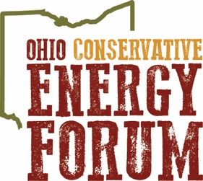

Embargoed Until:
February 11, 2020

OHIO CONSERVATIVE ENERGY FORUM TESTIFIES AGAINST SENATE BILL 234
Proposal would move goalposts, create unprecedented hurdle on business investment

COLUMBUS, OHIO --- Earlier today, the Ohio Conservative Energy Forum (OHCEF) joined more than 500 opponents in offering testimony against Senate Bill 234.

In prepared remarks, OHCEF Executive Director Tyler Duvelius noted: “It is a constitutional right of Ohio landowners to have the liberty to use their land as they see fit – in a way that will personally benefit them … Our Constitution guarantees a right to property – it does not guarantee a right to a view.”

OHCEF’s main concerns regarding SB 234 include:

- Creation of unprecedented hurdles for private business investment.
- Potential for prohibiting more than 9.5 million dollars for rural school from materializing.
- Subjecting Fifth Amendment property rights to a vote.
- Causing uncertainty across Ohio farmers and other energy sectors.

OHCEF looks forward to continuing to work with members of the Ohio Senate Energy and Public Utilities Committee to promote economic growth while ensuring that landowner property rights remain protected.

A full version of Duvelius’ testimony can be viewed here.

###

Founded in 2015, the Ohio Conservative Energy Forum is a movement of conservatives who recognize the importance of clean energy as a solution to sustaining energy dominance, keeping our economy booming, and providing power to sustain the American way of life.

Contact: Tyler Duvelius, 513-582-4310, tyler@ohcef.org

